

School of Computing Science

CSC2102: Team Project

C08 Customer Day Report
Topic ID: 1
Project: Integrated appointment scheduling and communication system
Completed By: Team 24

Name | Student ID
Benjamin Loh Choon How | 2201590
Wang Rongqi Richie | 2201942
Neam Heng Chong Timothy | 2201291
Loo Siong Yu | 2201255
Lee Zheng Han | 2201085
Efilio Yodia Garcia | 2200516

Task distribution 2
Introduction 3
Background 3
Target User Groups 3
Project Overview 4
Project Deliverables 4
User Stories and Requirements 4
Implementations 7
Approach 7
Frontend 7
Backend 7
Database 7
REST API Endpoints 7
Appointment Scheduling Module 9
Email Sending Module 9
Unit Test Scripts 10
Testing 10
Deployment 10
Project Management 10
Past Sprints 10
Sprint 2 10
Sprint 3 11
Sprint 4 11
Sprint 5 11
Sprint 6 11
Timeline Review 11
Sprint retrospective 11
Sprint progress 12
Limitations 13
Notification 13
Security 13
Payment 13
Appointment date time filtering 13
Appointment service choices 13
Future Works 14
Notification 14
Security 14
Payment 14
Appointment date time filtering 14
Appointment service choices 15
Handover items list 15
Presentation format for Roadshow 15
Project Achievements 15
Conclusion 15
References 16
Appendix 17
Code review report 17
Avoid Abbreviations 17
Descriptive Function and Variable Names Over Code Comments 18
Write Compact Code 20
Avoid Creating Unnecessary Variables 20
Too much nested code kills readability 22
Appropriate Data Structure 24
Reusability 26
Consistent Coding Style and Naming Convention 31
Code Duplication 33
Keep It Simple 34
Screen snippets 35
Landing page 35
Register as a customer page 35
Customer and technician home page 36
Customer home page 36
Customer Schedule Appointment Page 36
Customer Profile Page 37
Customer “Add Aircon” modal form at Profile Page 37
Customer view existing Appointment Details Page 38
Coordinator home page 38
Aircon catalog page 39
Coordinator appointment view page 40
Coordinator send enquiry page 41
Customer appointment update page 42
Coordinator register technician page 43
Technician Dashboard 44
Technician Appointment Details 44

Task distribution
Group Member | Contributions
Benjamin Loh Choon How | - Final report, slide deck and GitHub readme
Wang Rongqi Richie | - Final report, slide deck and GitHub readme
Neam Heng Chong Timothy | - Final report, slide deck and GitHub readme
Loo Siong Yu | - Final report, slide deck and GitHub readme
Lee Zheng Han | - Final report, slide deck and GitHub readme
Efilio Yodia Garcia | - Final report, slide deck and GitHub readme

Introduction
The "Integrated Appointment Scheduling and Communication System" is a social enterprise initiative designed to empower and support low-income individuals in becoming skilled technicians in the air conditioning servicing industry. The project provides a platform for these individuals to access job opportunities, develop their skills, and improve their economic prospects. It aims to streamline appointment scheduling and communication processes within the industry, benefiting customers, technicians, and coordinators alike.

Background
The air conditioning servicing industry in Singapore faces challenges in job allocation and communication due to the diverse needs of customers and the logistical constraints of technicians. To address these challenges, the project initially aimed to leverage messaging applications like WhatsApp for notifications and communication. However, limitations in accessing the WhatsApp Business API led to a strategic shift towards using email as the primary communication channel.
The revised approach focuses on developing a user-friendly web application for appointment scheduling, viewing, and rescheduling. This application serves as a centralized platform for customers to access services without the need for additional app downloads or visits to external web pages. Additionally, the project includes a technician management algorithm to efficiently assign technicians based on their skills, location, and availability.

Target User Groups
This project caters to three main user groups: customers, technicians, and coordinators. Customers are individuals from the general public in Singapore who have registered for the air conditioning maintenance service. Technicians are disadvantaged air conditioning servicing professionals who will utilize the web portal to accept air conditioning servicing assignments from customers. Coordinators, on the other hand, are the web portal administrators responsible for overseeing all operations through the web portal.

Project Overview
This project aims to create a platform that would provide more job opportunities for disadvantaged job seekers in the air conditioning servicing industry in Singapore. The initial plan involved proactively sending air conditioner (aircon) service notifications to customers through messaging mobile applications such as WhatsApp. This approach was designed to bring convenience to customers by allowing them to access services without the need for additional app downloads or visits to external web pages.
However, due to the scale of the company, we encountered challenges in accessing the WhatsApp Business API, leading to a strategic revision. The revised project exclusively utilizes email as the designated notification channels. Customers are required to access our web application for activities such as booking, viewing and rescheduling the appointments. This approach aims to maintain a seamless and user-friendly experience while overcoming the limitations associated with the original plan. The web application serves as the centralized platform for customers to engage with our services, ensuring efficient appointment scheduling without the need for additional application downloads or visits to external web pages.

Project Deliverables
- Project source codes
- Source code documentations
- User training materials
- Final report containing design specifications and details

User Stories and Requirements
Event name | User story | Requirement | Status
Service registration confirmation | As a customer, I want to know if I have successfully signed up for the service. | The webpage needs to have a login function for the customer to access the content. | Done
Regular servicing notification | As a customer, I want to get notified when I need to schedule a regular aircon servicing. | A notification should be sent to the customer when near the next aircon servicing date. | Not included
Aircon service booking | As a customer, I want to be able to book aircon servicing appointments. | The webpage should allow the customer to book aircon servicing appointment. | Done
Aircon service data/time browsing | As a customer, I want to be able to browse the available dates and time for aircon servicing. | The webpage should allow the customer to browse the available date and time when booking the appointments. | Partial
Aircon service data/time selection | As a customer, I want to be able to select the available date and time slot for aircon servicing. | The webpage should allow the customer to select the desired data and time when booking the appointments | Done
Aircon service rescheduling | As a customer, I want to be able to reschedule my existing appointment. | The webpage should allow the customer to change the appointment date and time after the appointment is booked. | Done
Aircon service add-on | As a customer, I want to be able to purchase additional service during the servicing. | The webpage should allow the customer to indicate the service needed. | Not included
Aircon service complaint | As a customer, I want to be able to complaint about the issues during the servicing to the platform. | The webpage should allow the customer to feedback on the appointment during servicing. | Not included
Aircon service feedback | As a customer, I want to rate and feedback on the servicing done. | The webpage should allow the customer to feedback on the appointment after servicing. | Done
Aircon service payment | As a customer, I want to be able to pay for the service online. | The webpage should allow the customer to make payment online. | Not included
Aircon service payment refund | As a customer, I want to receive a refund for cancellation or issues in the service I paid. | The webpage should allow the customer to request for a refund. | Not included
Aircon service payment invoice | As a customer, I want to know how much I pay for what services. | The webpage should display the price of the service. | Not included
Aircon service appointment confirmation | As a technician, I want to know the details of the aircon servicing appointment assigned to me. | Notification should be sent to the technician when new appointment is being assigned. | Not included
Aircon service appointment assigning | As a technician, I want to be assigned to suitable service appointments as possible. | The system should automatically assign the appointment to suitable technicians. | Done
Aircon service appointment notification | As a technician, I want to get notified when there are upcoming appointments. | Notification should be sent to the technician regarding the details of the upcoming appointments. | Not included
Aircon service appointment cancellation | As a technician, I want to be able to cancel the assigned appointment if needed. | The webpage should allow the technician to reject the appointment assigned. | Done
Aircon service add-on confirmation | As a technician, when the customer purchases additional service, I want to know the details submitted by the customer. | The webpage should allow the technician to view the services selected by the customer. | Not included
Aircon service appointment checking | As a technician, I want to know the appointments assigned to me in advance. | The webpage should show the appointments assigned to the technician. | Done
Pay slip checking | As a technician, I want to know how much I earn after each service done. | The webpage should allow the technician to view the allowance of each appointment | Not included
Aircon service helpline | As a technician, I want to be able to seek for help if I am unable to handle certain task during the servicing. | The webpage should allow the technician to seek for help during servicing. | Not included
Aircon service history | As a technician, I want to be able to check and retrieve my servicing history. | The webpage should allow the technician to view the servicing history. | Done
Technician registration confirmation | As a technician, I want to know if I have registered successfully to the platform. | Notification should be sent to the technician regarding successful registration and login details. | Not included
Technician details update notification | As a technician, I want to get notified when my particulars are updated by the coordinator. | Notification should be sent to the technician when the particulars are updated. | Not included
Technician details update request | As a technician, I want to update my personal details. | The webpage should allow the technician to update the personal particulars. | Partial
Technician registration | As a coordinator, I want to register new technician to the platform. | The webpage should allow the coordinator to register for new technicians. | Done
Technician details update | As a coordinator, I want to update the particulars of the technicians. | The webpage should allow the coordinator to update the particulars of the technician. | Partial
Technician searching | As a coordinator, I want to search for a technician in the system by name or ID | The webpage should allow the coordinator to search the technician by name or ID. | Done
Advanced technician searching | As a coordinator, I want to search and filter for a group of technicians matching certain criteria. | The webpage should allow the coordinator to search the technician by other attributes such as location or availability. | Partial
Technician deletion | As a coordinator, I want to remove a technician from the system. | The webpage should allow the coordinator to remove technician from the system. | Partial
Manual appointment assignment | As a coordinator, I want to manually assign an appointment to a particular technician. | The webpage should allow the coordinator to assign appointment to technician | Done
Manual appointment updating | As a coordinator, I want to manually change the details of an appointment when needed. | The webpage should allow the coordinator to update the details of the appointment such as date, time and service. | Partial
Appointment searching | As a coordinator, I want to search for a particular appointment by ID. | The webpage should allow the coordinator to search for appointment by ID. | Partial
Advanced appointment searching | As a coordinator, I want to search for list of appointments matching certain criteria. | The webpage should allow the coordinator to filter appointments by various criteria e.g., location, type of service, status etc. | Done
Customer complaint management | As a coordinator, I want to step into solving the conflict between the technician and coordinator easily and effectively. | The webpage should alert the coordinator when a customer made a complaint. | Not included

Implementations

Approach
The development of this web application follows a structured approach that separates the user interface from the backend server. This division ensures a clear distinction between what the main users interact with and the underlying system that handles computation, data storage, and technician scheduling.

Frontend
The frontend of the application is implemented using React, a popular JavaScript library for building user interfaces. The project was bootstrapped with Create React App to provide a solid foundation. The application is structured around several components, including a main App component, Navbar, CoordinatorNavBar, DeleteAppointmentPopup, and BackgroundWallpaper, each responsible for different parts of the user interface and functionality. To interact with the backend Django API, Axios was used to make HTTP requests. This enabled the frontend to send data to the server, such as user and appointment information, and receive data, such as the list of appointments, to display to the users. Styling of the frontend application mainly consists of using components from Ant Design, which is a react components library, Material Tailwind just for the login and signup page and tailwind CSS overall.

Backend
The backend server consists of a database, Django REST API endpoints, an appointment scheduling module, an email sending module, and test scripts.

Database
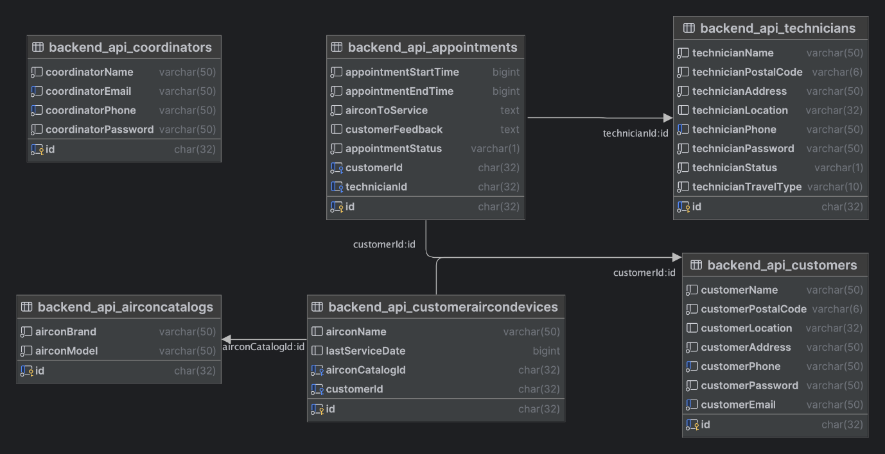

REST API Endpoints
The REST API has 6 endpoints:

domain/api/appointments/
GET /: Retrieves all appointments’ details or can be filtered by appointment ID, customer ID, technician ID, appointment status, customer name, technician name, appointment start time (in UNIX time format), customer phone number, customer email, technician phone number, customer postal code, technician postal code. Details including corresponding customer name, phone number, email, postal code, technician name, phone number, postal code, address, aircon selected to service, including aircon brand, model, name (given by customer).
POST /: Creates new appointment, a technician will be assigned by the appointment scheduling module and appointment status will be set to “confirmed”, otherwise appointment status will be set to “pending”.
POST /sendEnquiry/: Triggers message sending to customer registered email address.
GET /unavailable/: Retrieves a list of technicians near the registered location of the customer and their common unavailable date and time in UNIX time format.
PUT /: Updates the appointment by the appointment ID, without validation. This should only be used by the coordinator.
PATCH /: Updates an appointment by appointment ID, will trigger the appointment scheduling module to assign technician if needed, prioritising the original technician assigned if applicable.
DELETE /: Deletes the appointment by ID from the database.

domain/api/customers/
GET /: Retrieves all customers’ details or can be filtered by customer ID, email, name, postal code or phone number. Details including the aircon devices details (brand, model, name) registered under the customer.
POST /: Registration of new customer. Email and phone number need to be unique, password will be hashed by Django make_password function before storing to database. The location information, latitude and longitude, will be retrieved via OneMap API using the provided postal code.
POST /login/: Login using email and password. Password will be compared by Django check_password function.
PATCH /: Updates the customer’s details by ID.
DELETE /: Deletes the customer by ID from the database. Corresponding aircon devices and appointments will be deleted as well.

domain/api/technicians/
GET /: Retrieves all technicians’ details or can be filtered by technician ID, name, postal code, phone number, status and travel type.
POST /: Registration of new technician. Phone number needs to be unique, password will be hashed by Django make_password, location information will be obtained.
POST /login/: Login using phone number and password.
PATCH /: Updates the technician’s details by ID.
DELETE /: Deletes the technician by ID from the database. Corresponding appointments will be deleted as well.

domain/api/coordinators/
GET /: Retrieve all coordinators’ details.
POST /: Creation of new coordinator.
POST /login/: Login using registered email and password.
PATCH /: Updates the details of the coordinator by ID.
DELETE /: Deletes the coordinator by ID from database.

domain/api/airconcatalogs/
GET /: Retrieve all aircon brand/model details.
POST /: Creation of new aircon brand/model.
DELETE /: Deletes the aircon brand/model by ID from database.

domain/api/customeraircondevices/
GET /: Retrieve all customer aircon devices details.
POST /: Creation of new customer aircons.
PATCH /: Updates the details of the customer’s aircon by ID.
DELETE /: Deletes the customer’s aircon by ID from database.

Appointment Scheduling Module
The appointment scheduling module consist of 3 major parts:

geo_onemap
Construction of the request to OneMap API to get the latitude and longitude of the provided postal code, and the request to find the shortest route from one location point to another location point. Travel type can be specified, including “walk”, “drive” and “cycle”, routes will differ if different travel type is provided. API key is required for getting the routes, but not for getting the location information. Function will attempt to call the get_api_key to renew the API key if does not exist or expired.

get_api_key
Function to get the API access key using the credentials from the .env file. Upon successful retrieval, API key will be updated in the .env file and reloaded to the server.
The credentials for obtaining the API key are:
Email: pure.onemap.api@gmail.com
Password: waemyUQFHmH212o

scheduling_algo
Functions to get technicians near given location registered under customer, filtering the common unavailable data time, check if a timeslot is available for given technician, and to assign available technician to appointment. If multiple technicians are available, technician with least number of assigned appointments will be prioritised, otherwise, a random technician will be selected from the available technicians.

Email Sending Module

Sending_enquiry_email
Function to allow the coordinator to be able to send an ad hoc enquiry email to a customer for a specific appointment, however the viewing of emails on this web application is not possible.

Unit Test Scripts
The test scripts are to test the implemented functions, as part of the Test-Driven Development process. Basic functions such as database object creation are generally covered in the test cases.

Testing
The testing implementation for this project encompasses a comprehensive approach to ensuring the functionality, reliability, and user-friendliness of the web application. Various types of testing, including user acceptance testing (UAT) and functional testing, were conducted to validate different aspects of the system. UAT test cases were developed to simulate real-world scenarios for different user roles, such as customers, technicians, and coordinators, ensuring that the application meets their specific needs and expectations. Functional testing was used to verify the correct behaviour of key features, such as appointment scheduling, user registration, and profile management. Additionally, automated testing scripts were utilized for unit testing to streamline the testing process and improve efficiency. Overall, the testing implementation aimed to deliver a high-quality, error-free application that meets the requirements and expectations of its users.

Deployment
The deployment of the "Integrated Appointment Scheduling and Communication System" involved hosting the backend Django REST API on Microsoft Azure and deploying the frontend React application on Vercel. Azure was chosen for its robust infrastructure and scalability, providing a reliable environment for the backend API to handle user requests, manage data, and interact with the database. Vercel, on the other hand, was selected for hosting the frontend due to its ease of use, seamless deployment process, and support for static sites and React applications. By leveraging these platforms, the project was able to achieve a stable and efficient deployment, ensuring that the application is accessible, responsive, and secure for users.

Project Management
The project management approach for the "Integrated Appointment Scheduling and Communication System" follows an agile methodology, structured around six sprints. Agile principles such as iterative development, continuous feedback, and adaptability were key drivers throughout the project lifecycle. Each sprint focused on delivering specific features and functionalities, with regular sprint planning, daily stand-up meetings, and sprint reviews to track progress and make adjustments. The agile strategy allowed for flexibility in responding to changing requirements and priorities, ensuring that the project remained aligned with the goals and expectations of stakeholders. By adopting this approach, the project team was able to effectively manage the development process, deliver incremental value, and maintain a high level of collaboration and communications.

Past Sprints

Sprint 2
In this sprint, we gathered the requirements from the customer and is aimed to target for three user groups which are customers, technicians and coordinators. Our project was to allow customers to make an appointment and it will search for a nearby technician who is available. Coordinators can help to manage the appointments between customers and technicians too.
We created a list of user case where it helps us to find out the functions that we may need in order to ensure that the application meets the customers’ needs.
Our team used GitHub as a file sharing platform where our team can collaborate and work on the same project simultaneously. We have also set up a Telegram Group to update each other on the progress of our parts.

Sprint 3
The team presented our progress on the project, focusing on architectural design, WhatsApp integration, and database considerations. The team tested features that was request by the customer, whilst checking the limitations of each feature. During this customer day, we had also let the customer know on the constraints that we had in terms of implementing certain features and got back suggestions on how we can tackle this issue.

Sprint 4
The team started initial implementation of the web application. We had created basic functionalities to kickstart the project. Some were experimenting with possible implementations methods of certain features such as Cronjob and Amazon SNS. However, the team overlooked a problem within the WhatsApp API that we wanted to implement and eventual

Sprint 5
In this customer day, we have completed most of the functions which allows us to perform a CRUD function for different components such as appointments, customers, technicians, aircon catalogue, coordinator. Our team is working on implementing the technician matching algorithm to the appointment schedule. We were also performing tests and checking for bugs to ensure that the application works smoothly as well as improving on the UI UX design of the application.

Sprint 6
The team's primary focus was on integrating multiple components and implementing final functionalities for the web portal. We conducted integration tests and system tests before proceeding with deploying both the frontend and backend applications to the cloud.

Timeline Review
During Sprint 7, the team focused on finalizing the project by completing documentation for both the source code and working on handover documents. This included the final project report and the presentation slide deck for the road show.
The project readme was updated to include a brief description of the project along with detailed instructions to install and run the project. Additionally, detailed deployment instructions for the frontend application to Vercel and the backend application to Microsoft Azure were provided.
At the request of our client, we also included a section documenting the pain points we faced during development for this project. This comprehensive documentation ensures that the project can be easily understood, maintained, and handed over to the client or other stakeholders.

Sprint retrospective
Mad 😡 | Siong Yu: Nil  Benjamin: Nil  Richie: Nil  Timothy: Nil  Zheng Han: Nil  Yodi: Nil
Sad 😞 | Siong Yu: Nil  Benjamin: Nil  Richie: Nil  Timothy: Nil  Zheng Han: Nil  Yodi: Nil
Glad 😀 | Siong Yu: Glad that the product is developed to a degree that the customer is satisfied with it.  Benjamin: Glad that the product is developed and delivered successfully despite some obstacles.  Richie: Nils  Timothy: Glad that the product is developed and delivered successfully to the customer.  Zheng Han: Nil  Yodi: Glad that the product is developed and delivered despite having several problems in the early stage.

Sprint progress
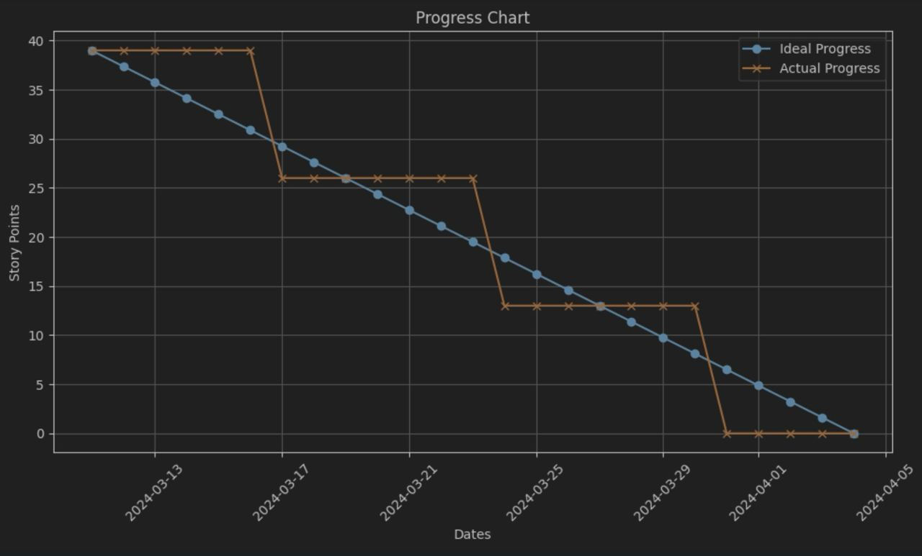

Limitations
Due to the lack of time and experience, many features are not implemented or partially implemented. This section will address some of the important features missing in this project.

Notification
Notification features are not implemented at all despite of its importance. It provides timely updates, confirmations and reminders that improves user experience when using our website. Coordinators, technician and customers will all have a better time using our website if notifications were to be implemented. However, due to lack of time, we couldn’t implement it.

Security
Due to time constraints and the prioritization of getting the project deployed onto the cloud, only simple encryption of passwords was implemented as a security measure. While this approach provides a basic level of security by encrypting passwords before storing them in the database, other security measures could be implemented like JWT token authentication and CSRF token authentication for forms.

Payment
The implementation of payment features, including invoice, payslips has not been implemented at all in our project currently. Even though payment is a big aspect of our project, it has not been implemented due to time constraints.

Appointment date time filtering
Appointment date time filtering does not work as of now, perhaps due to the data being saved in UNIX timestamp format. As the filtering feature is implemented with the material-react-table library, there are some constraints on the features of the table that might have some relation to the difference in the actual data being iterated and how the data is being displayed on the table.

Appointment service choices
We have yet to allow customers to choose what type of services they require. All appointments right now are just general appointments, which allow us to test the matching algorithm for our technicians and customer. This appointments services feature will allow us for better pricing and payment system and more customization of our appointments

Future Works

Notification
Notifications on upcoming appointments can be implemented via email and SMS (using Amazon SNS). We have previously tried these methods of notifying the customers and automating the sending using cronjob. For future implementation, we can explore how cronjob can automatically add new Jobs every time an appointment is created and to automatically send a notification to the customer within a reasonable time span to remind the customer of their upcoming appointments.
Besides traditional notification services, as most members of the public now owns smart phones, and calendar event can be integrated instead. By implementing an Internet Calendaring and Scheduling (ICS) downloadable object into the webpage, a calendar event prompt will be opened for the customer upon downloading the file. This can potentially be an easier way to implement the notification feature. More tests and research should be carried out to evaluate on the compatibility of such feature on different kinds of devices and the acceptance by the public.

Security
To further enhance the project’s security, implementing more advanced security measures such as JSON Web Tokens (JWT) and Cross-Site Request Forgery (CSRF) would be beneficial. JWT can be used to enhance authentication by securely transmitting information between parties as a JSON object. It can help improve the security of the application by ensuring that requests are coming from authenticated users and by providing a secure way to transmit user information. Additionally, implementing CSRF protection can help prevent unauthorized requests from being sent from a user's browser without their knowledge. This can be achieved through techniques such as generating and validating CSRF tokens for each request, which can help mitigate the risk of CSRF attacks. By incorporating these security measures into the application, future iterations can improve the overall security posture and better protect user data.

Payment
For implementing a payment system, we recommend leveraging APIs such as Stripe to facilitate seamless transactions. While Stripe does entail a transaction fee, its infrastructure offers numerous advantages, including secure payment processing, fraud prevention measures, and seamless integration with various platforms. Additionally, utilizing Stripe's services will provide us with automated invoices, streamlining our transaction tracking processes and enhancing financial transparency. This approach ensures efficient payment handling while minimizing administrative overhead, ultimately contributing to a smoother and more reliable payment experience for both our business and our customers.

Appointment date time filtering
For implementing the date time filtering, perhaps the date time can be saved in another way other than the UNIX timestamp. The material-react-table library might then be able to filter the value properly.
The backend server has the functionality of filtering common unavailable datetime implemented. The frontend server will need to have the functionality to retrieve the list when the customer opens a new booking page and filter the datetime to display the nearest available time slot. Given that the filtering of the common unavailable datetime can potentially be resource-draining, a cache and/or DDoS prevention mechanism may be needed as well.

Appointment service choices
To enhance our appointment services, we propose integrating a feature that enables users to select specific criteria when scheduling appointments. This includes options to specify the air conditioner brand and model, as well as the type of services required. By incorporating this functionality, appointments will be dynamically displayed on the technician dashboard according to the selected criteria, ensuring technicians are adequately prepared with the necessary tools and equipment for the task at hand. Moreover, this customization will enable us to accurately price appointments based on the specific requirements, mitigating the risk of under-pricing or overpricing our services. This tailored approach not only enhances operational efficiency but also enhances customer satisfaction by ensuring precise service delivery tailored to their needs.

Handover items list
Item | Description
GitHub Offline Archive of project | Contains all source code, README, and related materials for the project, ensuring access to technical details.
Documentation | Detailed documentation outlining the project's design, implementation, and usage instructions.
Training Materials | Materials to facilitate training on how to use the final product effectively.
Comprehensive Report | A detailed report providing insights into the project's inception, development process, and outcomes.
Presentation Slides (PDF) | Slides used in the roadshow to showcase the key features and achievements of our project.

Presentation format for Roadshow
The Roadshow for our CSC2102 Team Project marks the culmination of two trimesters of hard work and dedication. This event is a special highlight, showcasing the purpose behind our product's design, the methods employed in its construction, and the achievements attained throughout the project. The team will demonstrate our product’s capabilities and showcase how the project can solve the user stories uncovered.

Project Achievements
- Successfully carried out requirement gatherings in accordance to the problem statement & identified key user stories & requirements.
- Successfully converted the user stories & requirements to functionalities in our product.
- Overcame setbacks regarding initial product ideation.
- Successfully developed & delivered the Minimum Viable Product (MVP) of this integrated aircon appointment scheduling web application that meets all basic requirements as agreed.
- Successfully completed all necessary documentations needed for handover.

Conclusion
The CSC2102 Team Project, aimed at revolutionizing the air conditioning servicing industry, culminated in the development of an "Integrated Appointment Scheduling and Communication System." Initially set on utilizing messaging apps for communication, the team adeptly shifted to an email-based system in response to accessibility challenges, showcasing remarkable flexibility and resilience. This pivot resulted in a centralized, user-friendly web platform that streamlines the appointment process for customers, technicians, and coordinators without necessitating additional downloads.
Throughout the project, our agile methodology guided us through iterative development, enabling adaptation to feedback and refining the application to meet key user needs effectively. Despite time constraints and initial experience limitations, significant features like the technician scheduling algorithm and email functionalities were successfully implemented. Acknowledging future opportunities for improvement, such as enhanced notification systems, security measures, and an integrated payment function, our work lays a solid foundation for subsequent enhancements.
As we approach the roadshow, reflecting on our journey reveals a tale of collaboration, innovation, and a deep commitment to impacting the air conditioning servicing industry positively. Our project not only addresses logistical challenges but also aims to improve the economic prospects of disadvantaged individuals in Singapore. The "Integrated Appointment Scheduling and Communication System" stands as a testament to our team's hard work and the potential for further development and positive change in the community.

References
https://www.django-rest-framework.org/
https://react.dev/
https://ant.design/docs/react/introduce
https://www.material-tailwind.com/ (for login and registration page design)
https://tailwindcss.com/
https://www.onemap.gov.sg/apidocs/
https://azure.microsoft.com/en-us
https://vercel.com/

Appendix

Code review report

Avoid Abbreviations
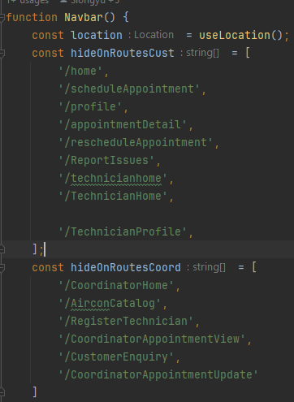
There are a few minor abbreviations in the variable names in navbar.js such as hideOnRoutesCust and hideOnRoutesCoord. These variable names could be more descriptive by replacing hideOnRoutesCust with hideOnCustomerRoutes and hideOnRoutesCoord with const hideOnCoordinatorRoutes.
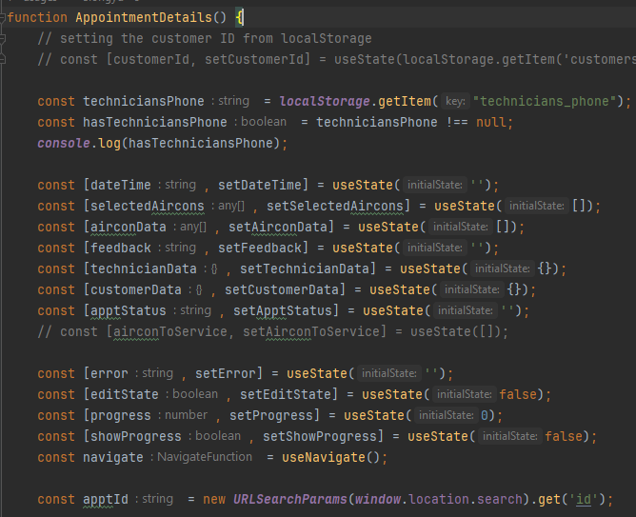
In AppointmentDetail.js, there is a minor abbreviation in the variable name apptId. This variable name could be more descriptive. A better name might be appointmentId.
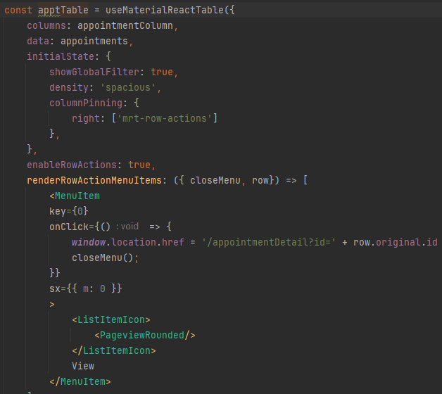
In the Home.js file, there is an instance where a variable name is abbreviated. For example, apptTable. While this abbreviation might be clear to the current developer, it might not be clear to other developers who might work on this code in the future. A suggestion is to rename this abbreviation to its full form which is appointmentTable.

Descriptive Function and Variable Names Over Code Comments
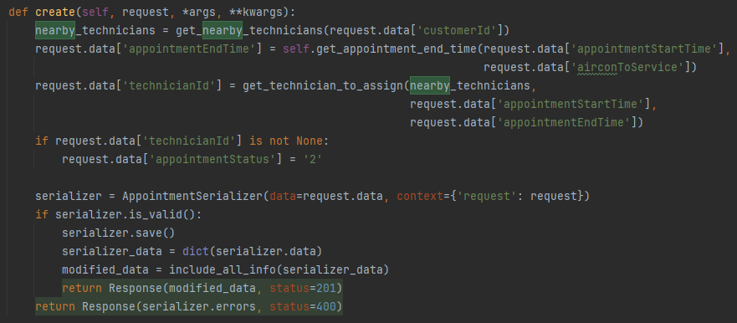
In the AppointmentViewSet class, the create method uses a variable named nearby_technicians. This variable name could be more descriptive. A better name might be available_technicians_nearby, which more clearly indicates that these are the technicians who are available and located near the customer.
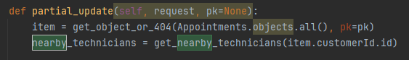
In the AppointmentViewSet class, the partial_update method uses a variable named item. This variable represents an appointment object. A more descriptive name might be appointment_item.
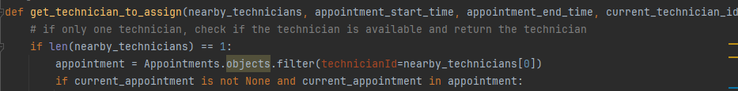
In the get_technician_to_assign function in scheduling_algo, the variable appointment is used to represent a list of appointments for a technician. A more descriptive name might be technician_appointments.
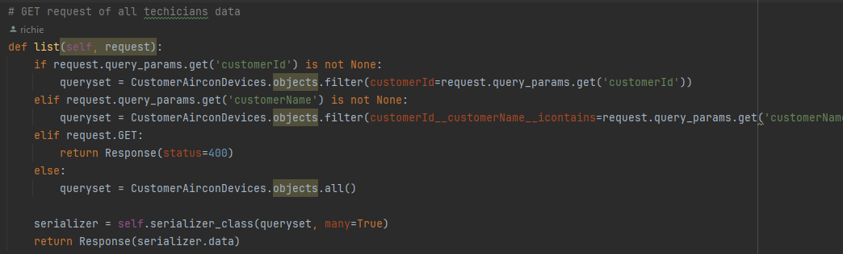
In the CustomerAirconDeviceViewSet class, the list method uses a variable named queryset. This variable name could be more descriptive. A better name might be customer_aircon_devices_query.
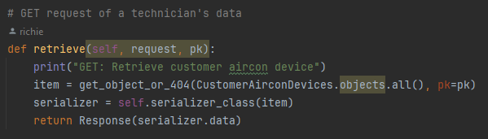
In the CustomerAirconDeviceViewSet class, the retrieve method uses a variable named item. This variable represents a customer aircon device object. A more descriptive name might be customer_aircon_device.

Write Compact Code
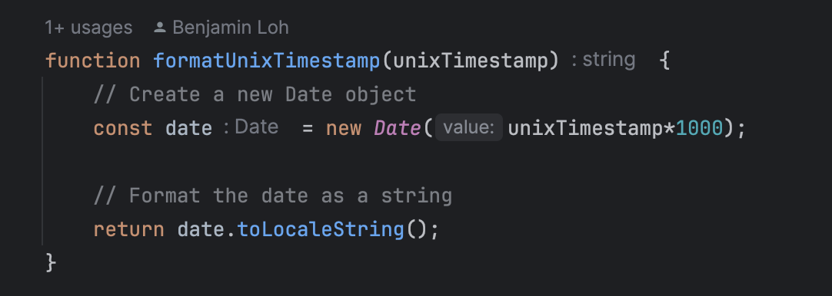
Repeated Code: The function formatUnixTimestamp is repeated in many pages. This function could be moved to a utility file and imported when needed, reducing code duplication.

Avoid Creating Unnecessary Variables
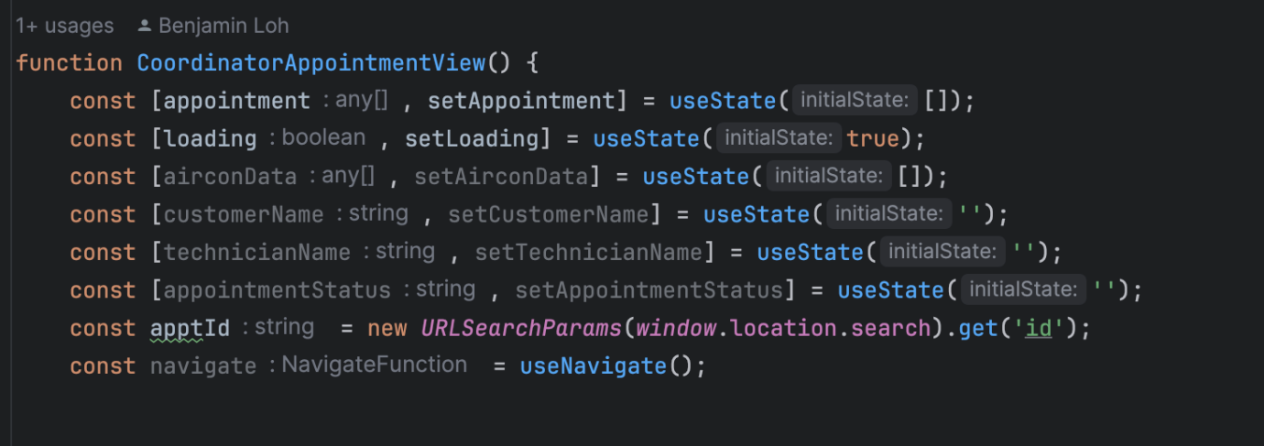
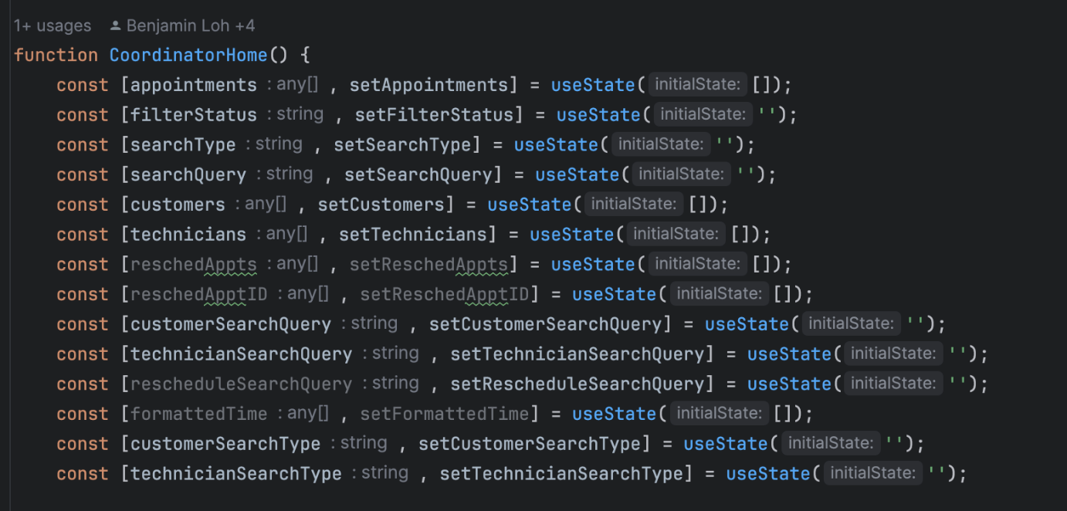
Unnecessary useState Variables: There are multiple useState variables such as airconData, customerName, and technicianName that do not seem to be used in the codes across many files. If these variables are not used elsewhere in the code, they could be removed.
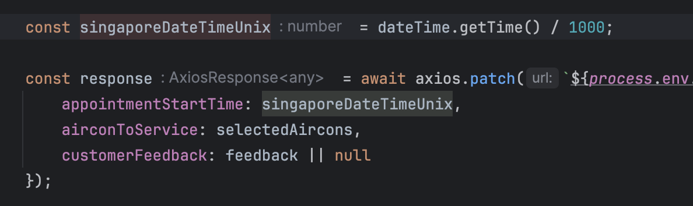
Unnecessary Variables when creating request body: For all the functions involving sending the unixtimestamp, a const variable is created to hold the value. While the variable is not being used anymore afterwards, the vaiable singaporeDataTimeUnix is redundant.
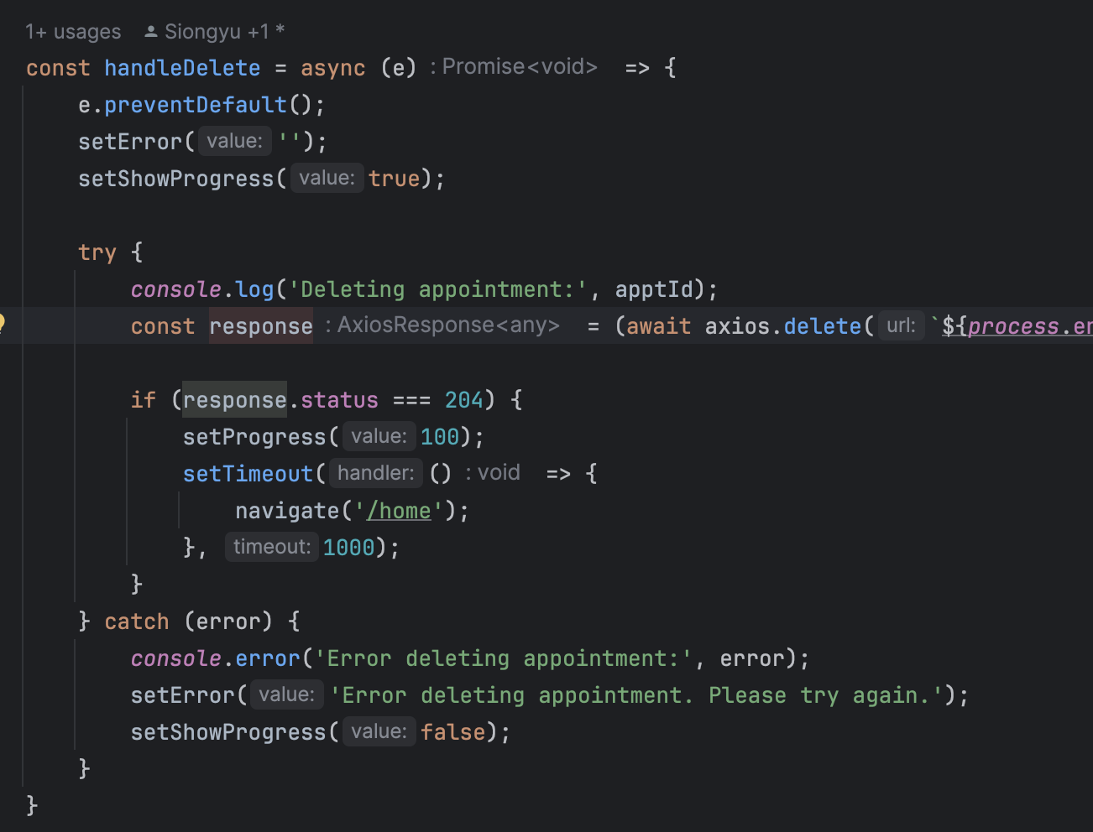
Unnecessary response creation while handling redirect: The response in many files for API call and then redirect is redundant as the response is not being used anymore in the page other than getting the status, instead of creating a response variable, the status can be directly accessed in the ‘if’ block. This issue appears many times for all the delete and cancel functions across many files.

Too much nested code kills readability
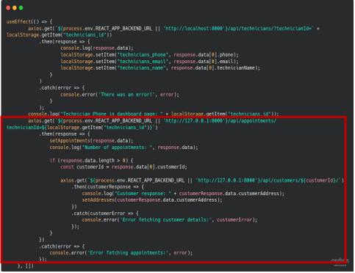
In TechnicianHome.js, the red border area under the useEffect hook, the code contains nested code and it can be unreadable at times when one is trying to debug the code if ever an error or bug arises. Although this is one way to get data through axios library API call methods. A much readable way would be to use await asynchronous way to retrieve data via the API URL endpoints.
The refactored code would be:
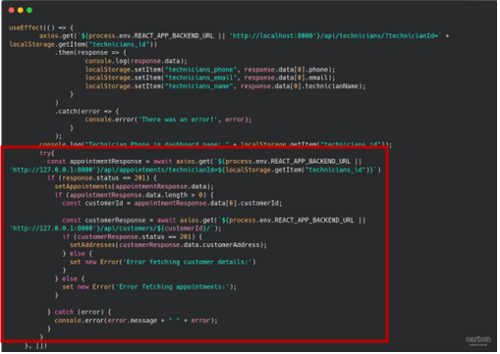
The refactored version reduces the nested from 4 to 3. Which helps to eliminate the code to be too clustered, making it slightly readable.

Appropriate Data Structure
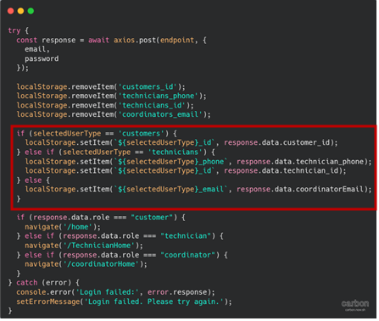
In Login.js, the red border area under the handleSubmit function upon login, for the selectedUserType == ‘technicians’, it should either be localStorage.setItem of the technician phone or the technician id and not both because it is redundant to add both. In this case, setting the technician_id would be more appropriate than setting the technician_phonenumber.
The refactored code would be:
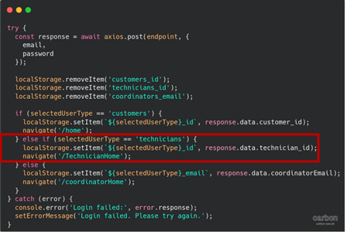

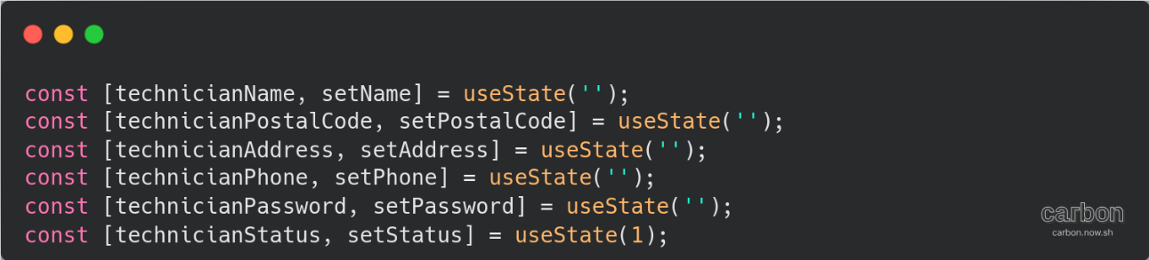
In RegisterTechnician.js, there are numerous useState of a technician detail spanning from the name, postalCode to the status. Having numerous useState can make the whole code to be messy so to refactored it, an appropriate data structure can be use in place such as having a useState of technician object containing the different details of the technician.
The refactored code would be:
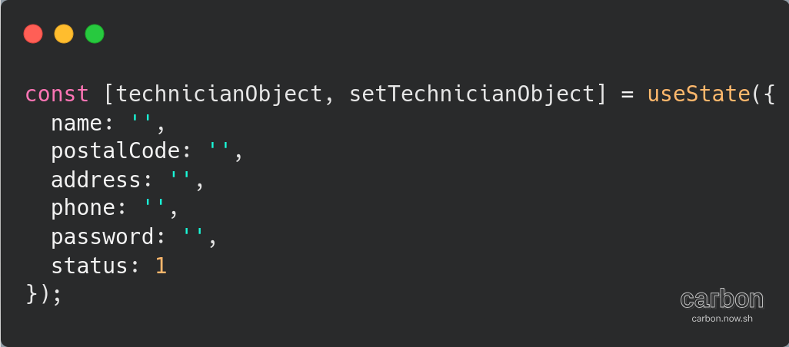
This way, there is only one useState variable inside the javascript file instead of numerous useState variables.
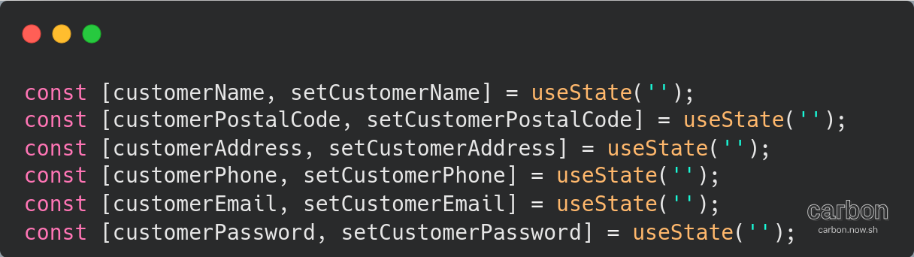
Likewise, in Register.js, there are numerous useState of a customer registration detail. Instead of having numerous useState variables, it would be better to have an appropriate data structure which is a customer useState object that contain the different details.
The refactored code would be:
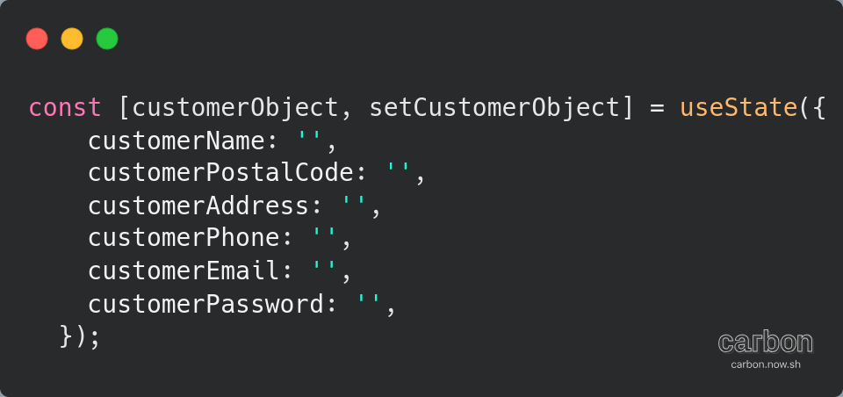

Reusability
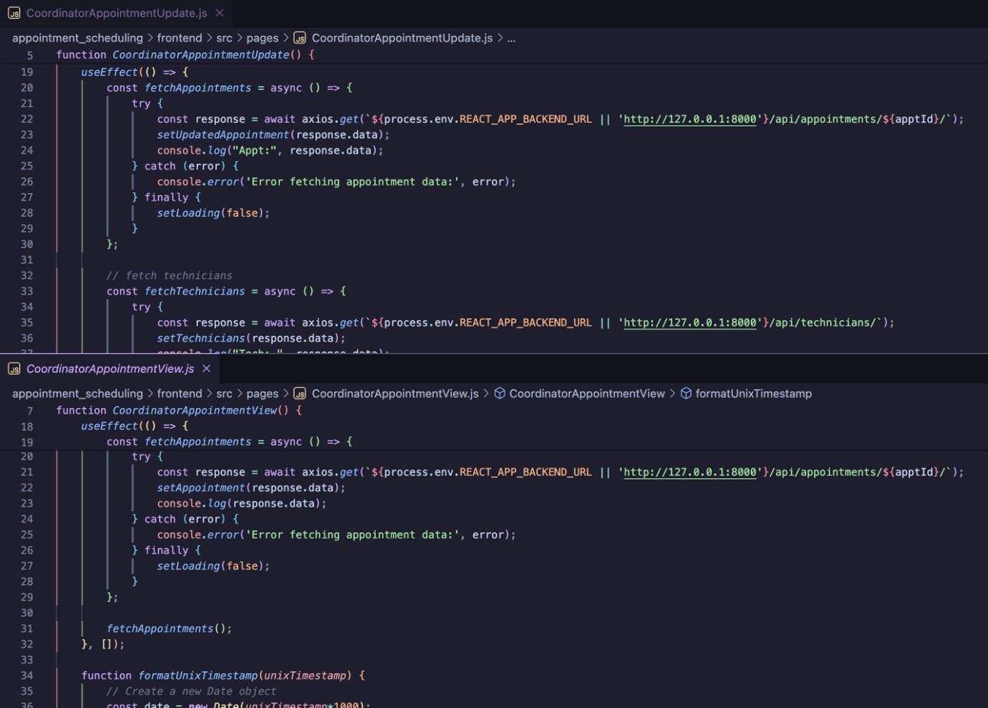
There is a line of code which has been used by both “CoordinatorAppointmentUpdate.js” at line 22 and “CoordinatorAppointmentView.js” at line 21, this code that are in the red box is trying to get one unique appointment by putting the appointment id into the appointment API call. This would return all the data of that appointment.
One way to refactor the code is to put that line of code into a function in a file called “getData.js”. This would allow for reusability of the function just by calling it from “getData.js” file. Maintainability and updating of that function would also make developers life easier because they do not have to manually search and find all the files that uses the same line of codes
In the GetData.Js file, we import react and axios and we create an export async function called getAppointmentByID with the parameter apptId, this function will return the data of that requested appointment.
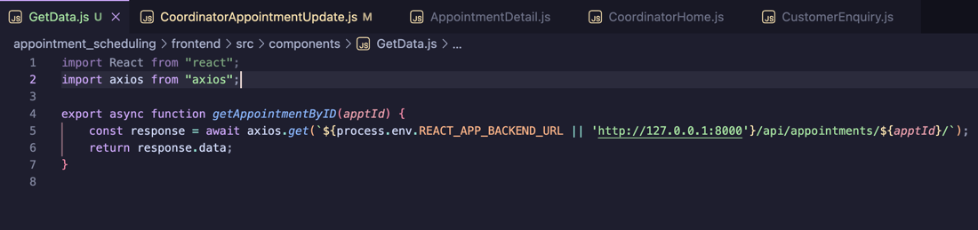
In the CoordinatorAppointmentUpdate.js file, we import the function getAppointmentByID from the GetData.js file at the top at line 4. at line 23 and 24, we replace the existing query with a
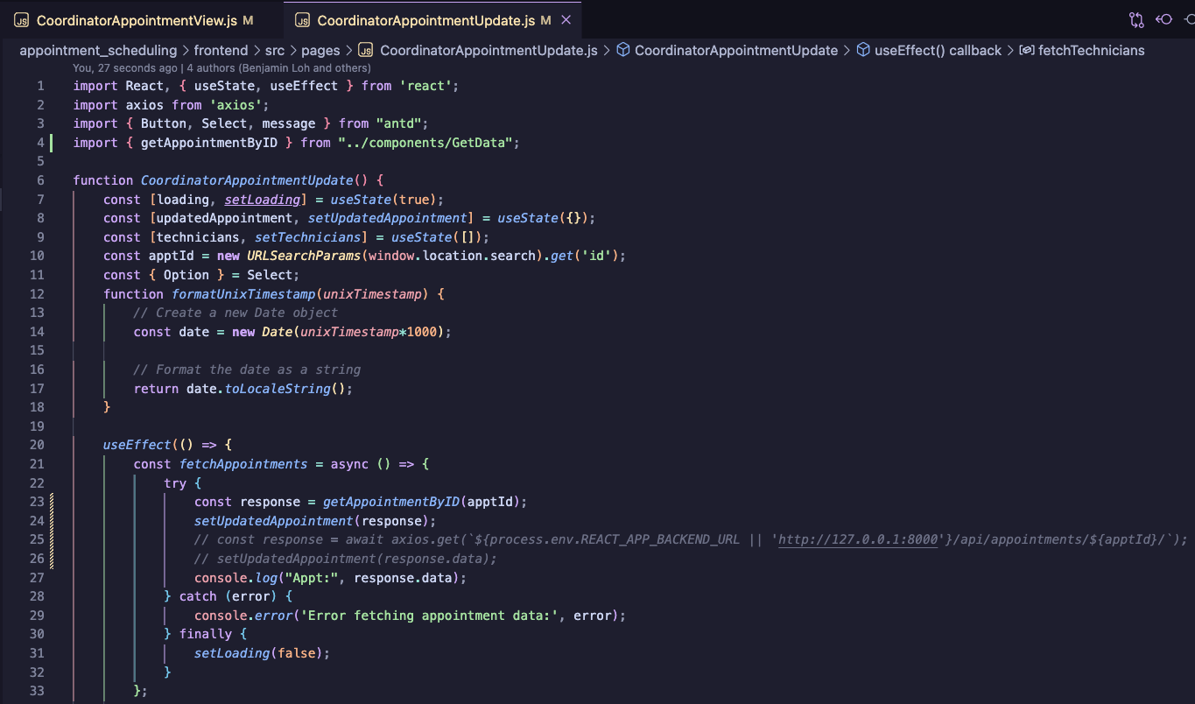
In the CoordinatorAppointmentView.js file, we add the import at the top at line 6, then at line 22 and 23, we add a constant response and call the function from the getData.js file.
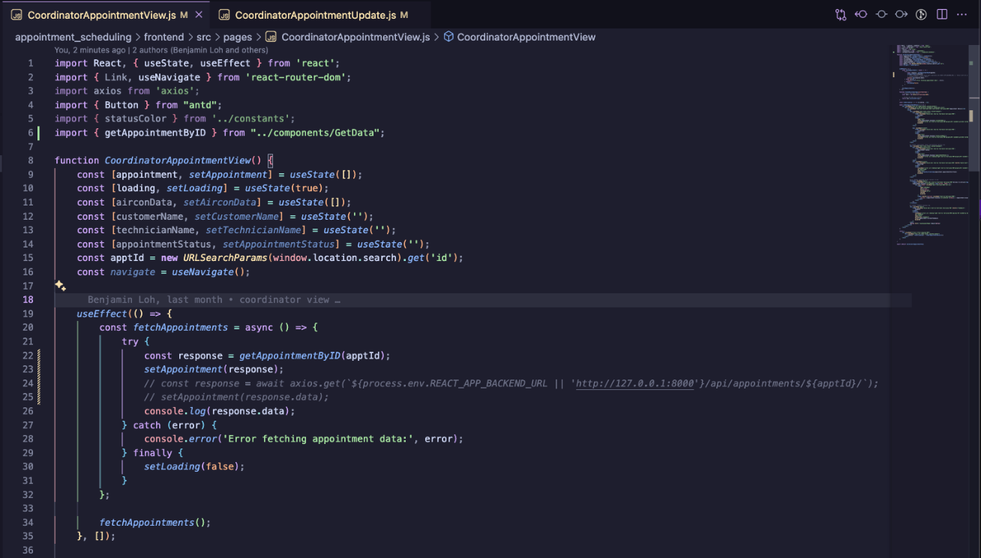
Similarly, in “TechnicianHome.js” and “TechnicianProfile.js” file, there is an API call requesting to get a technician information based on their id in the local storage. This line of code has been used in 2 different files. Creating a new function in “GetData.js” file would allow the function to be reused anywhere if the correct file is imported.
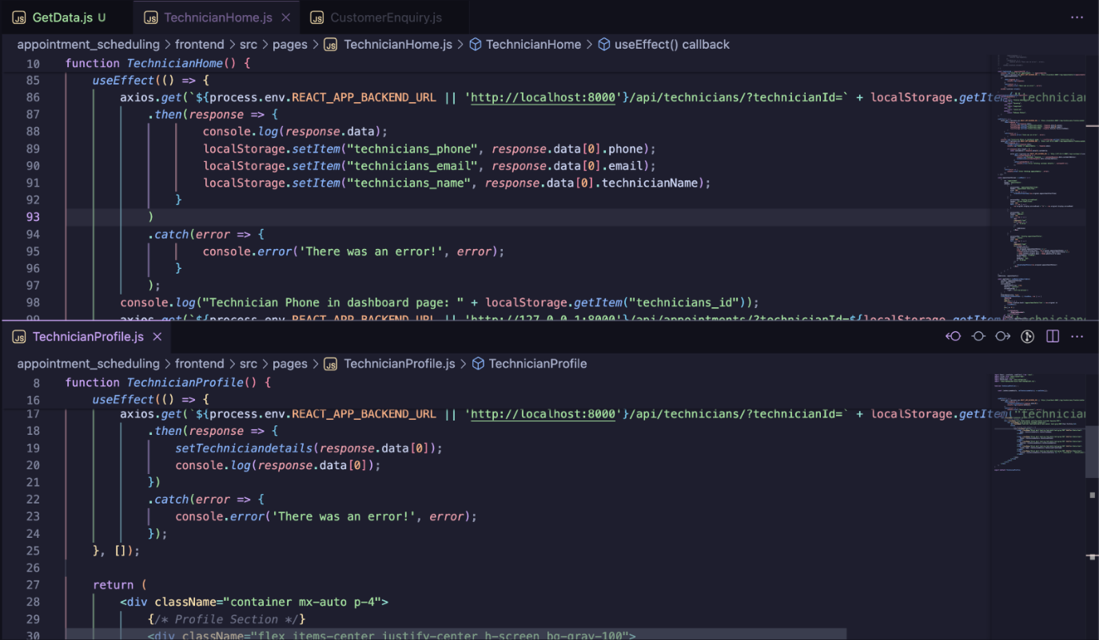
To refactor the code, at the GetData.js file, we add a new function called getTechnicianByID which will return us the data of one technician based on their id that is taken from the local Storage. We do not need to add a parameter inside because the local Storage can be accessed from anywhere as long as there data in the local Storage called technician_id.
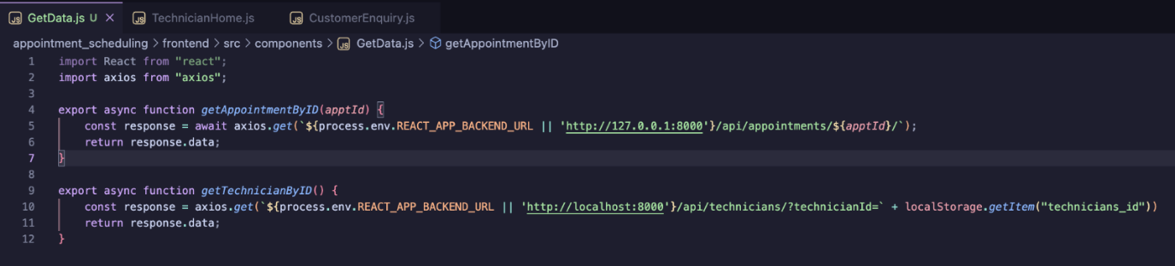
TechnicianProfile.js
In the TechnicianProfile.js and TechnicianHome.js, we import the file at the top and we call the function at the function when we need to get data of the technician at line 13
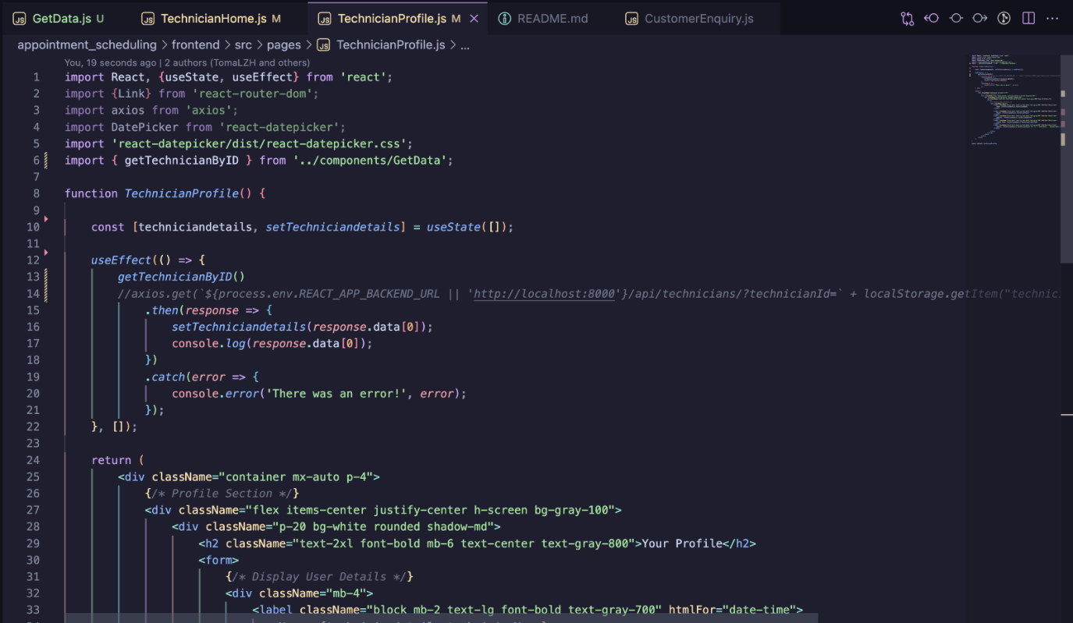
TechnicianHome.js
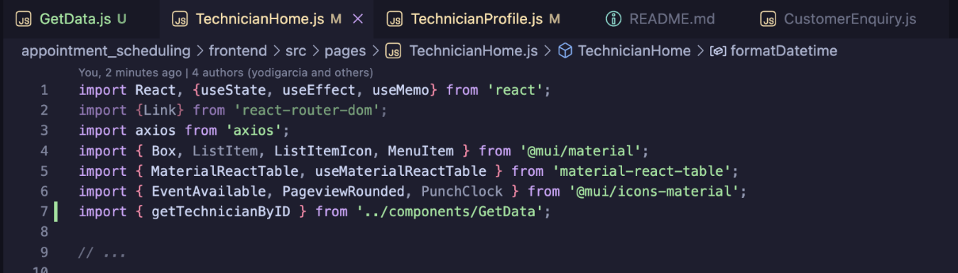
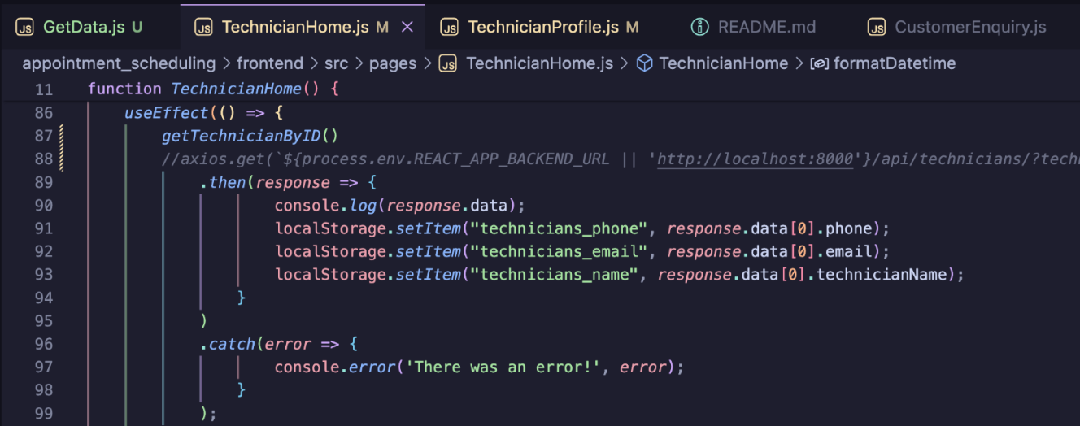
Another area where reusability can happen is in RescheduleAppointment.js and RescheduleCoordinator.js where both files use the same code to find the aircons a particular customer has.
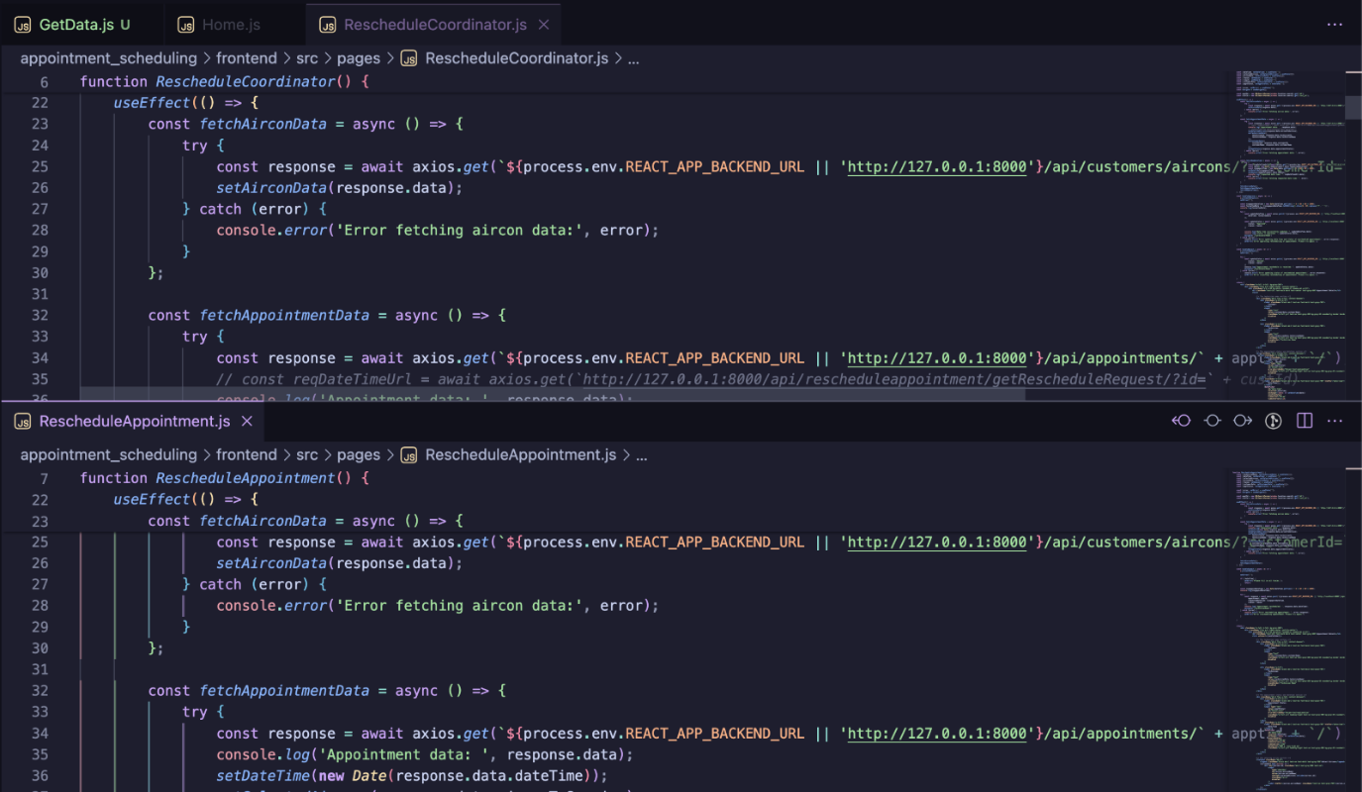
The refactor code would be to implement the function in GetData.js file that can be called from both RescheduleAppointment.js and RescheduleCoordinator.js file.
In the GetData.js file, we implement the function called getCustomersAircon()
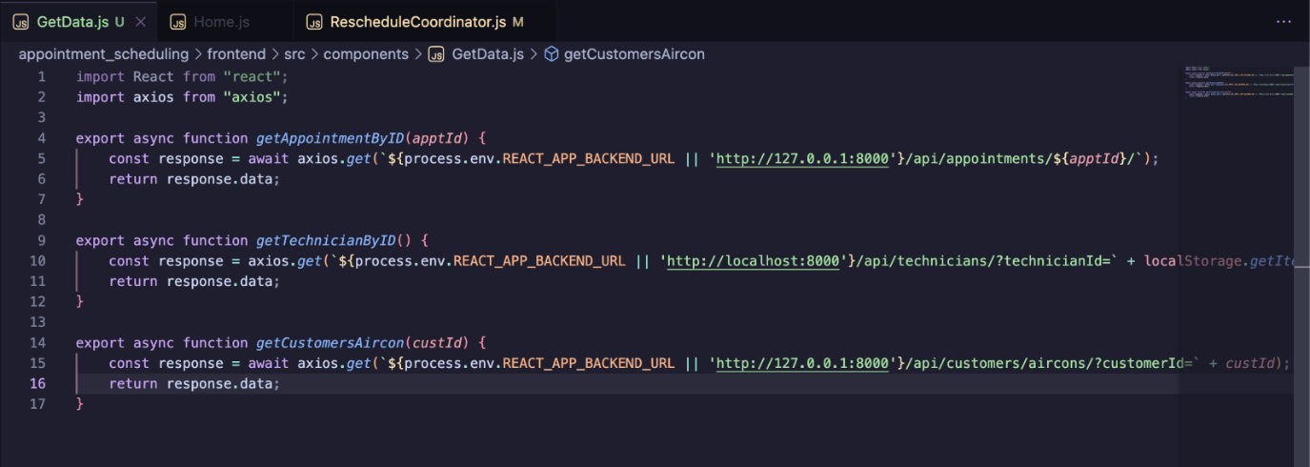
At the RescheduleCoordinator.js and RescheduleCoordinator.js file, we import the file and function
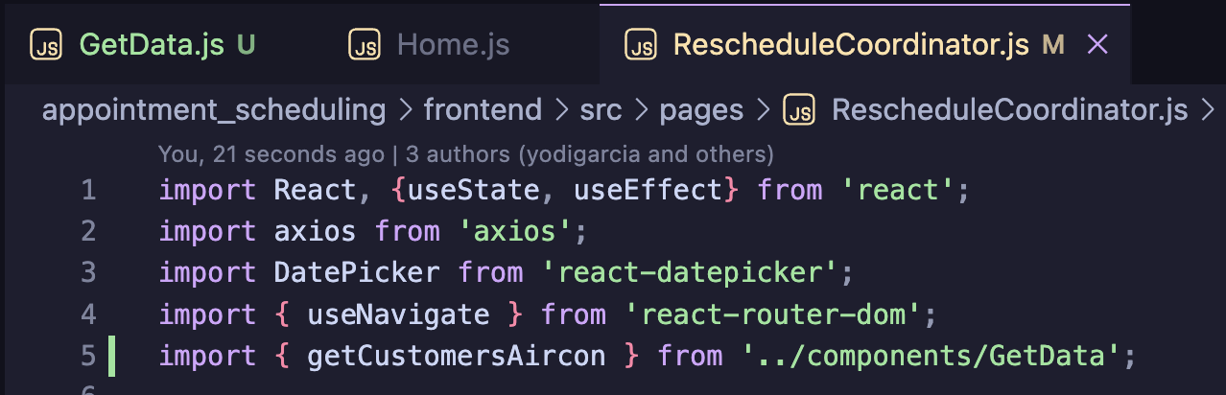
We call the function by putting const response = getCustomersAircon() where we need to get the data.
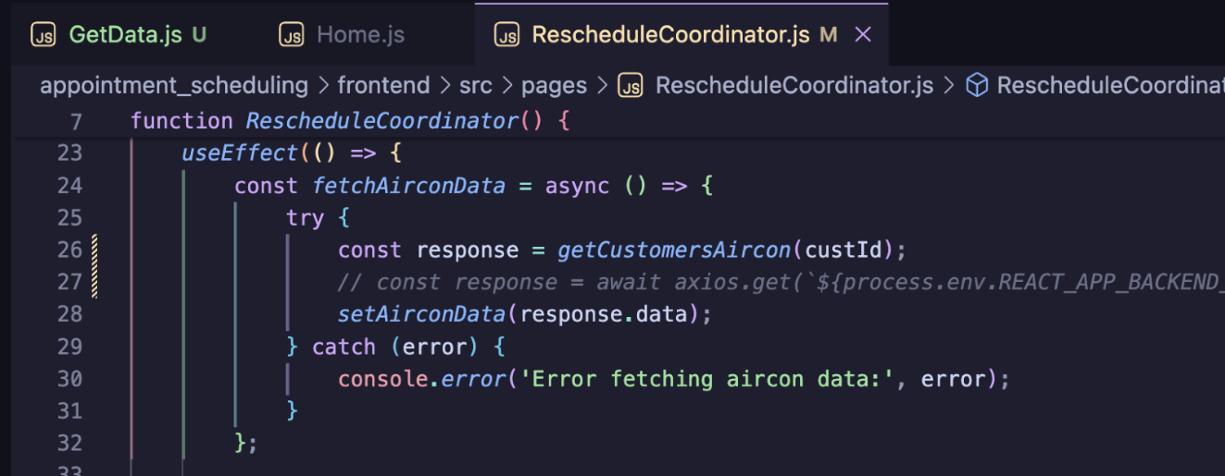

Consistent Coding Style and Naming Convention
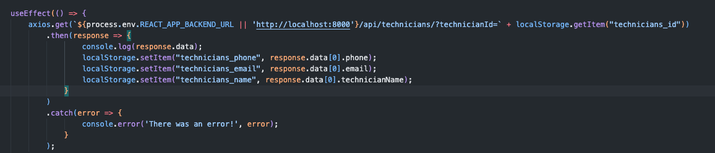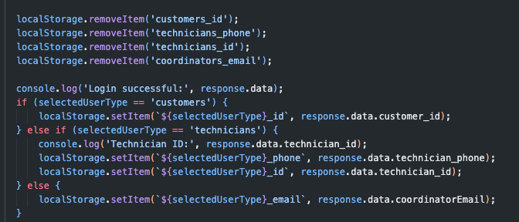In the screenshots shown above, naming conventions were not followed when storing values into the local storage. When storing and removing values to and from the local storage, values are stored as ”customers_id”, ”technicians_phone”, ”technicians_id”, etc. If we were to follow the naming conventions in the rest of the files, these values should be stored as ”customerId”, ”technicianPhone”, ”technicianId”.
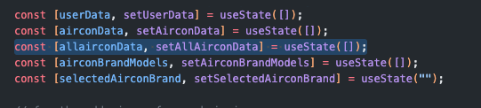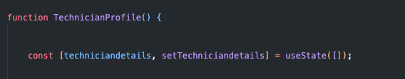
These are just some variables that do not follow the naming convention as well. “allairconData” and “techniciandetails” can be changed to “allAirconData” and “technicianDetails”.
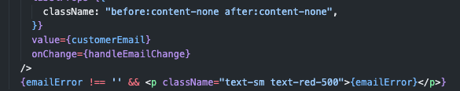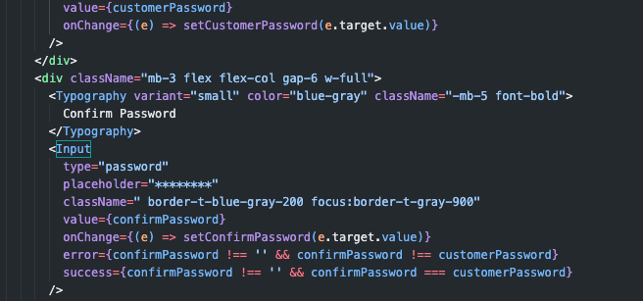From the picture above, handleEmailChange function is written differently compared to the codes written below it, where both onChange for customer password and confirm password contains the (e) events parameter where it will update the parameter of the function with the customer password and confirm password value respectively. This shows that there is inconsistency in the coding style. The correct way to write it would be:
onChange={(e) => handleEmailChange(e.target.value)}
Code Duplication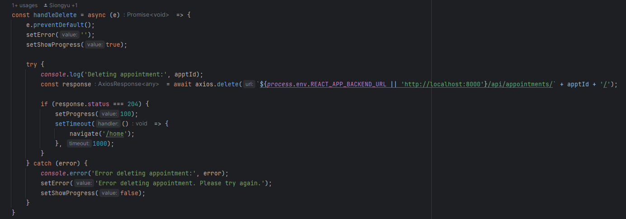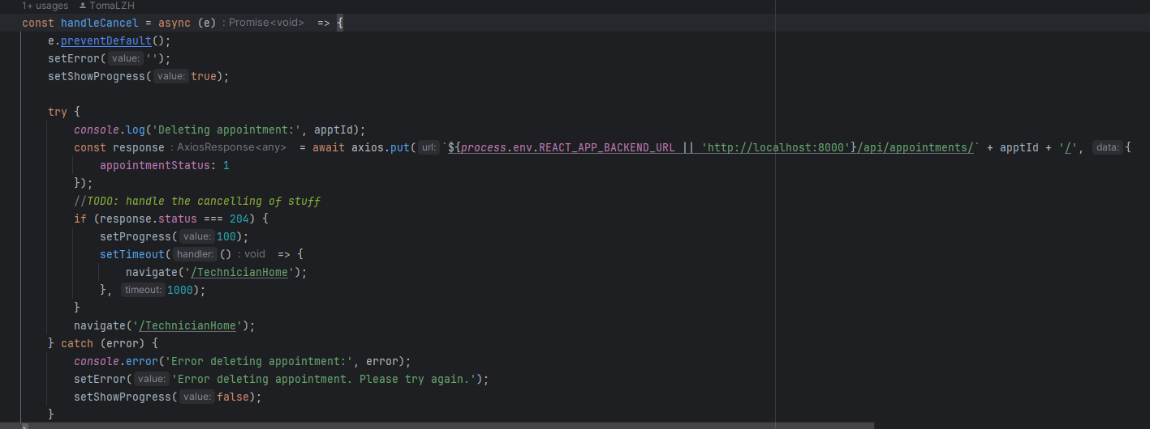
In AppointmentsDetail.js, there is a lot of code duplication in these two functions. We can combine them to 1 to prevent duplication.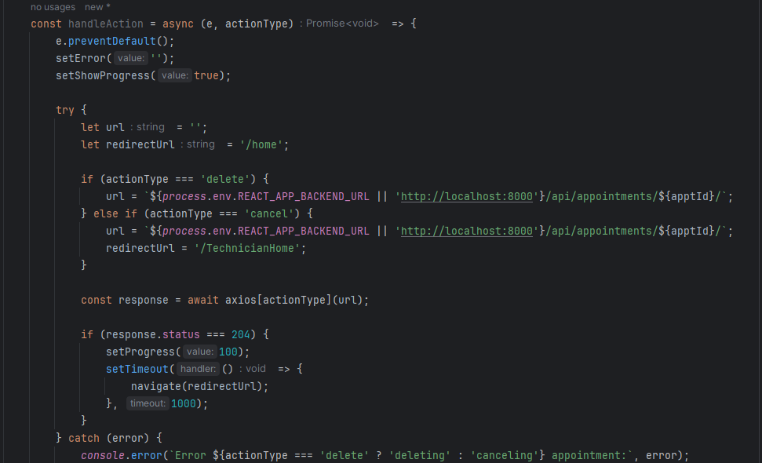

Keep It Simple
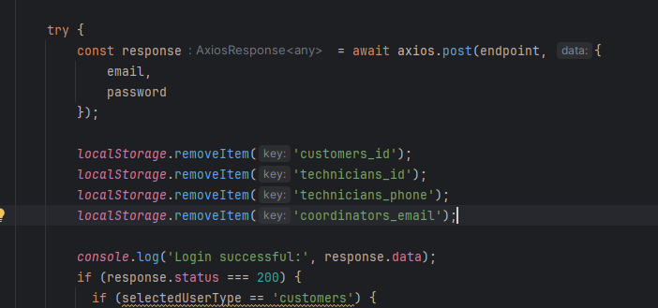Instead of removing localStorage one by one, we can just clear all using one function
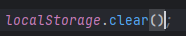

Screen snippets

Landing page
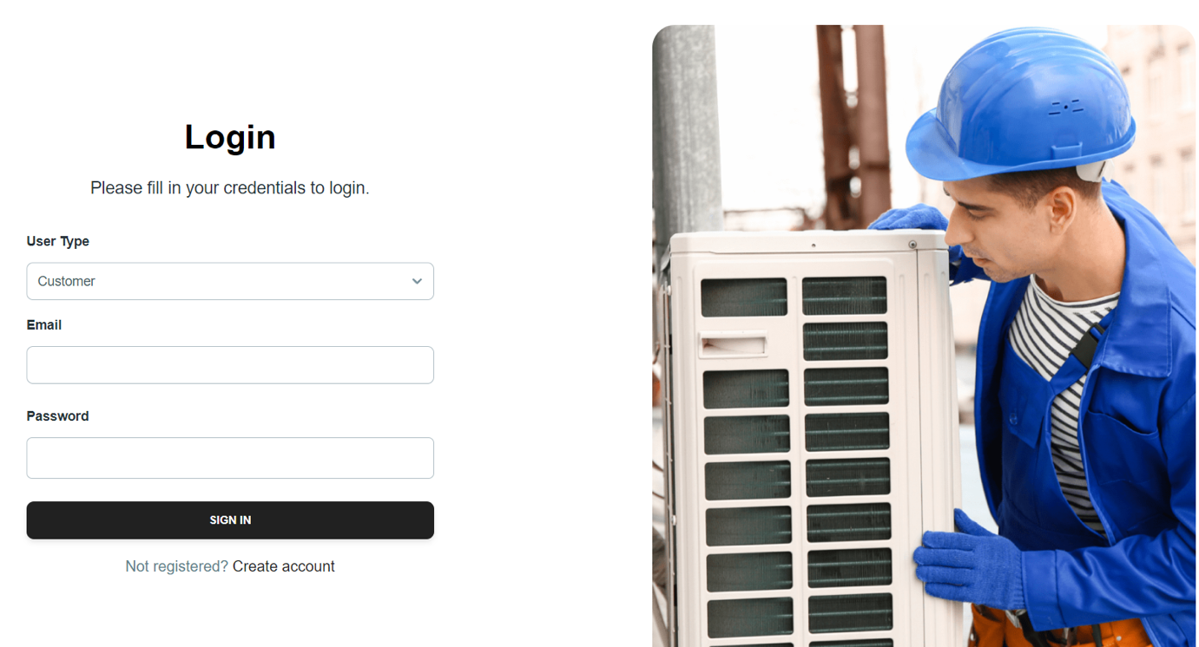

Register as a customer page


Customer and technician home page
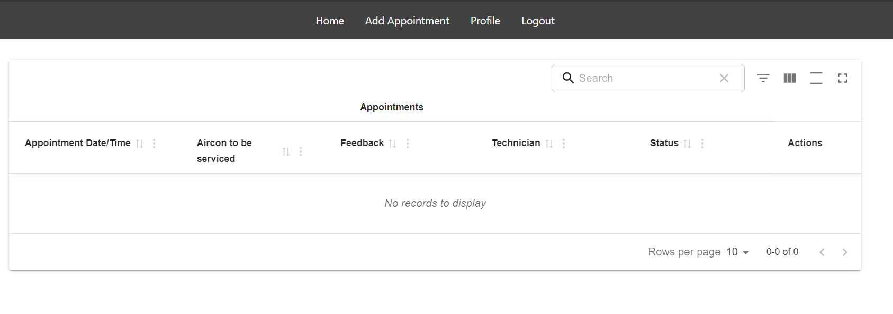

Customer home page
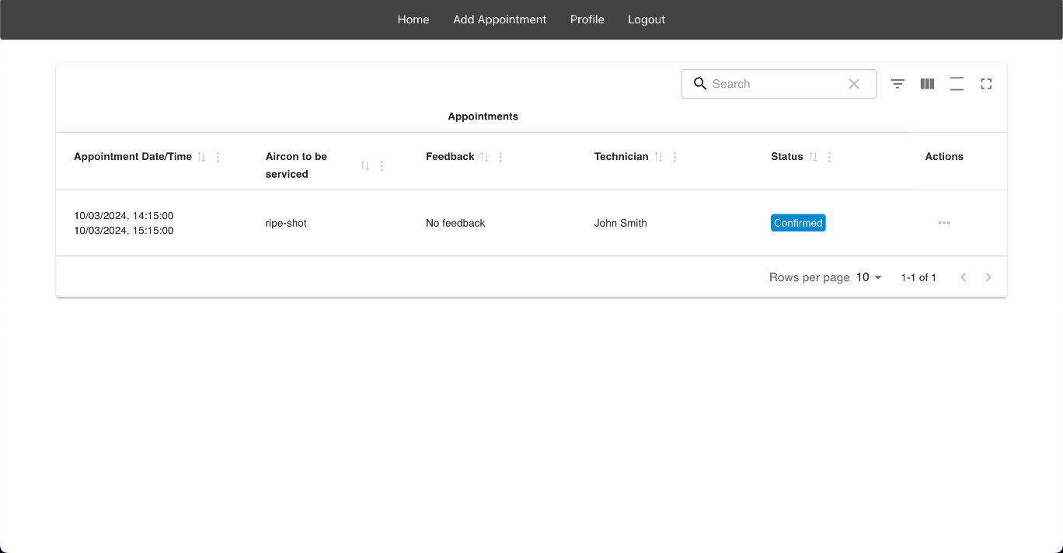

Customer Schedule Appointment Page
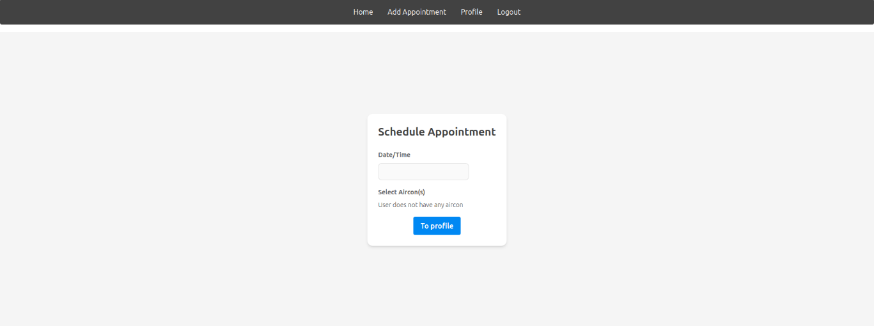

Customer Profile Page
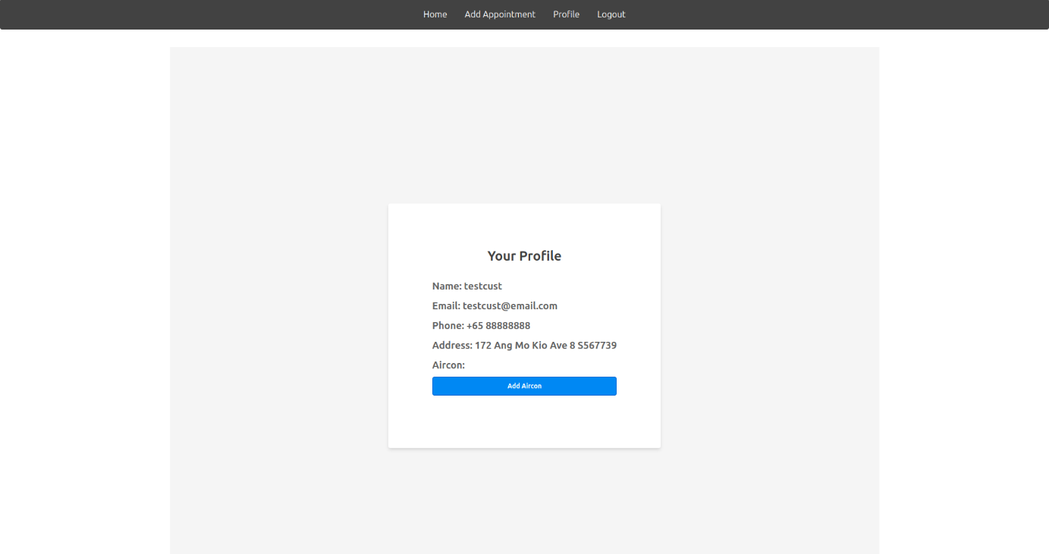

Customer “Add Aircon” modal form at Profile Page
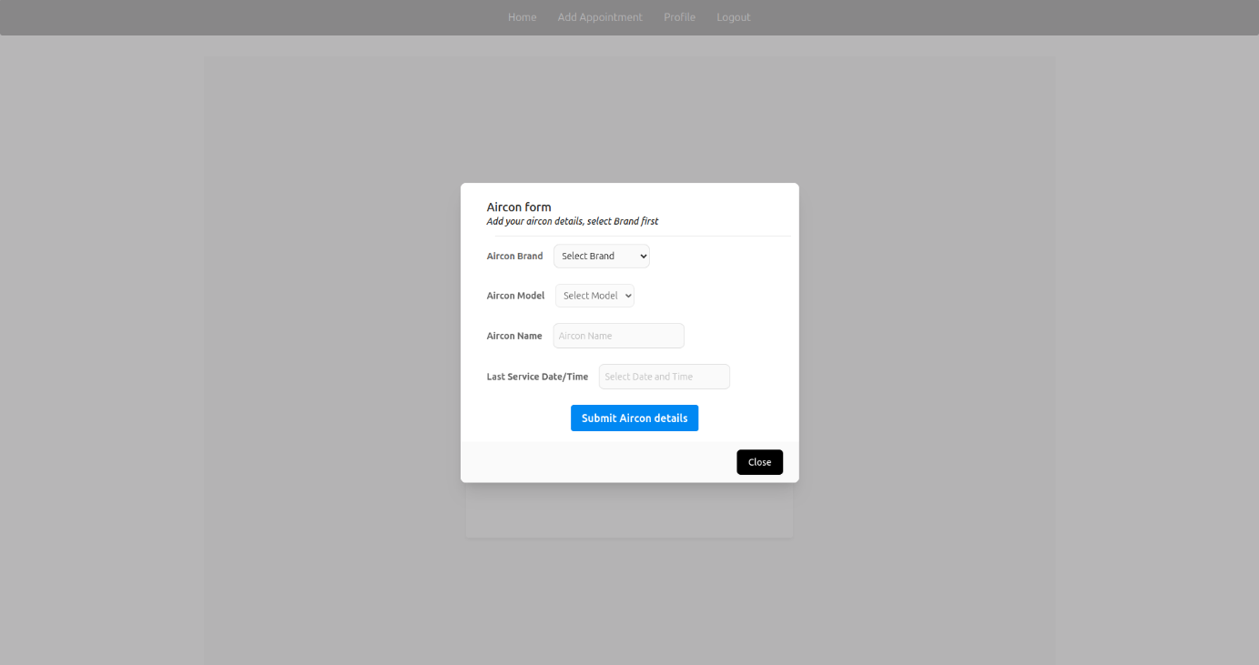

Customer view existing Appointment Details Page
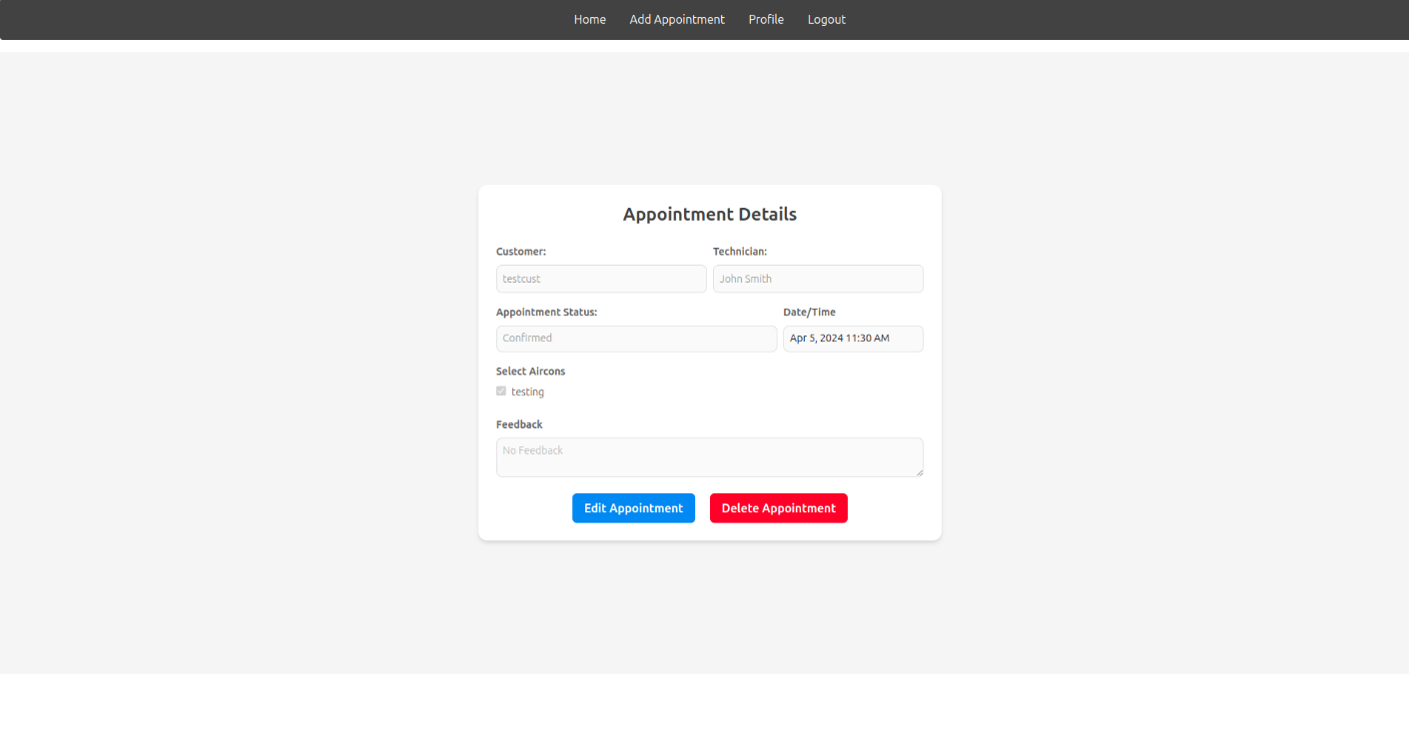

Coordinator home page
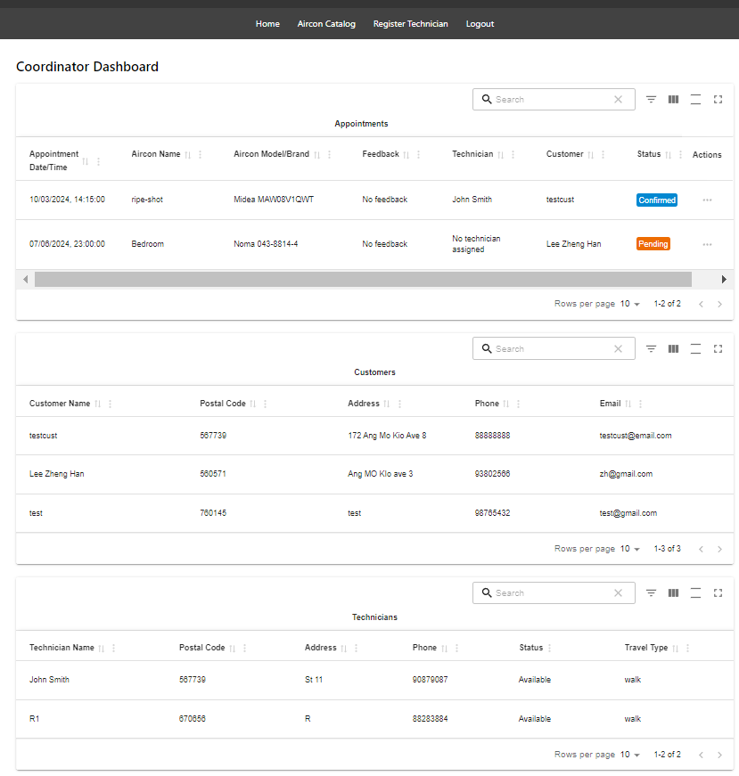

Aircon catalog page
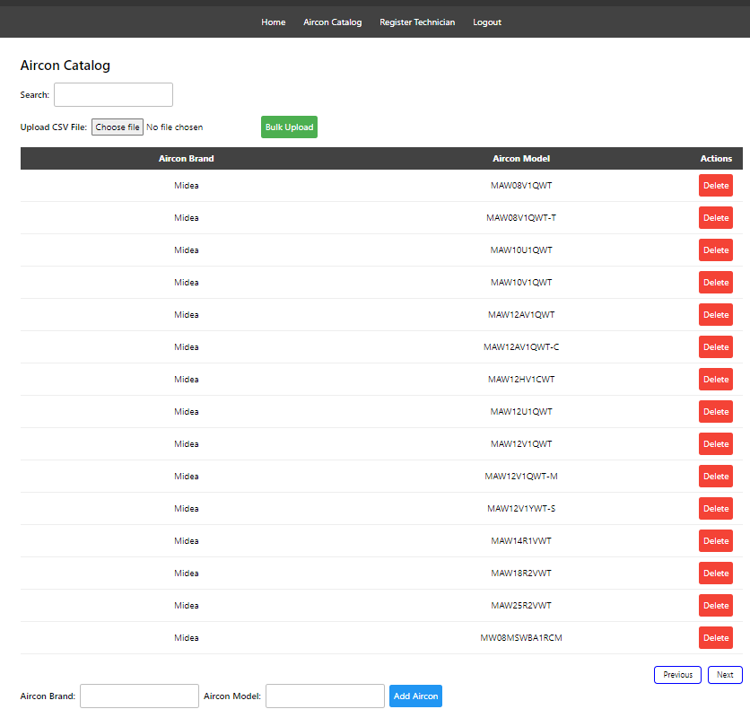

Coordinator appointment view page
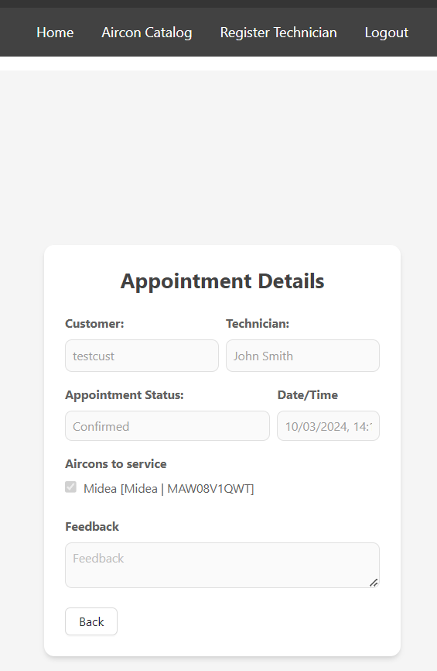

Coordinator send enquiry page
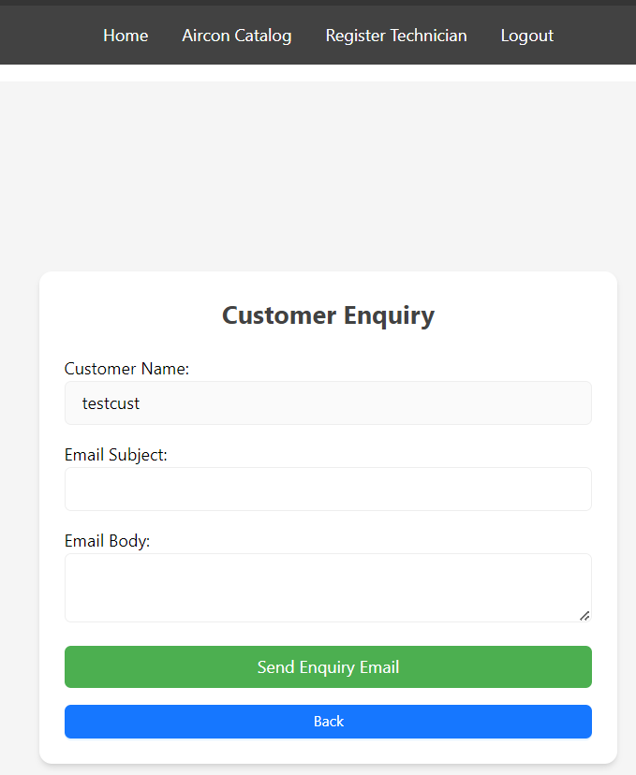

Customer appointment update page
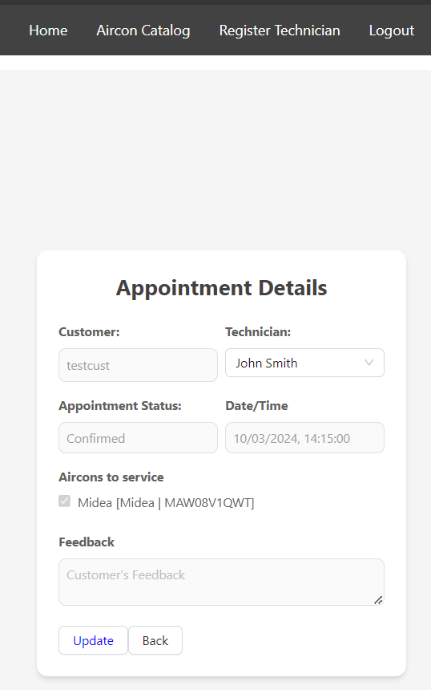

Coordinator register technician page
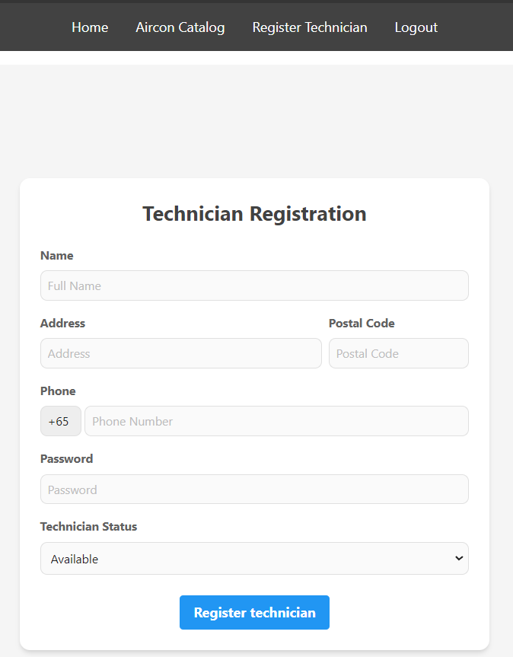

Technician Dashboard
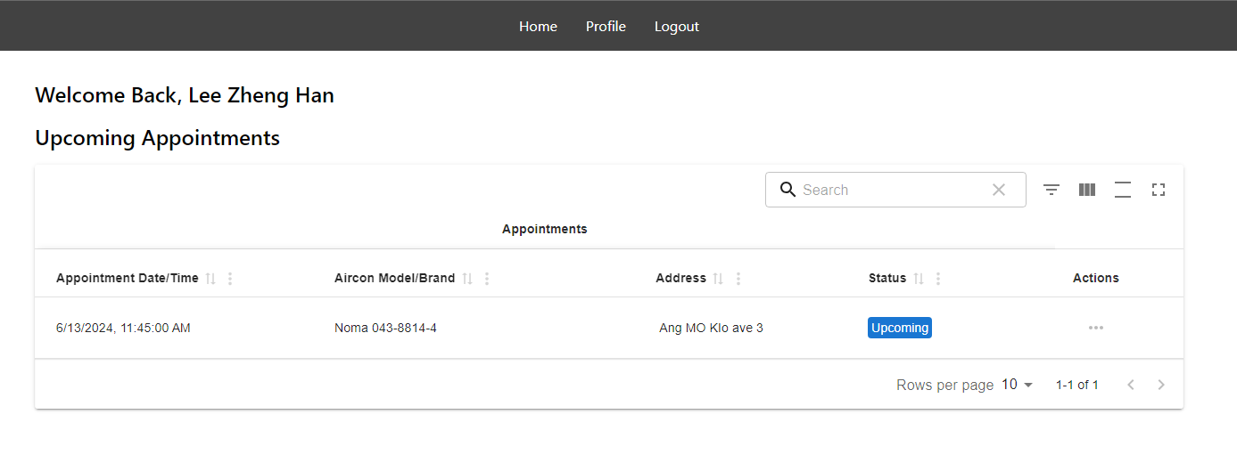

Technician Appointment Details
